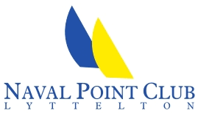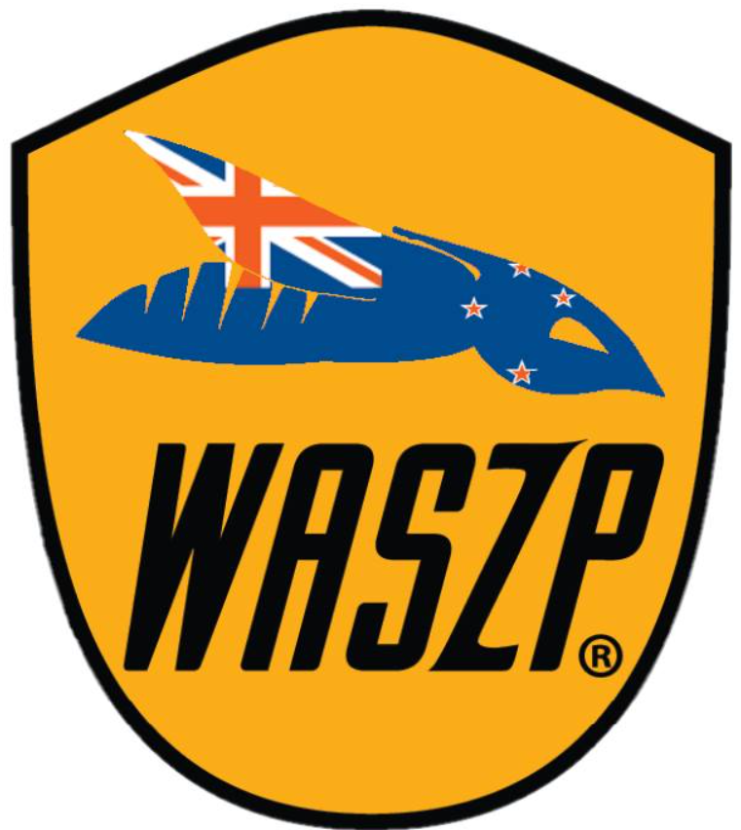

2025 New Zealand WASZP National Championships

# 14th – 16th March 2025

# ***Notice of Race***

**The Organising Authority is the Naval Point Club Lyttelton (NPCL)**

Naval Point | Lyttelton

NB: The notation ‘[DP]’ in a rule in the Notice of Race means that the penalty for a breach of that rule may, at the discretion of the protest committee, be less than disqualification and the notation [NP] in a rule in the Notice of Race means rules that are not grounds for protest by a boat*.*

1. **Rules**
   1. The event will be governed by the ‘rules’ as defined in the Racing Rules of Sailing (“RRS”) and the WASZP Class rules.
   2. The Yachting New Zealand Safety Regulations Part 1 shall apply.
   3. Appendix T shall apply.
   4. RRS 35, RRS 35, A4 and A5 may be changed in the Sailing Instructions to allow for a “Grand Prix Style” finish.
2. **Advertising [DP]**

Boats may be required to display advertising chosen and supplied by the Organising Authority.

1. **Eligibility and Entry**
   1. The event is open to boats of the WASZP Class and whose sailors are current financial members of their respective class association and National Member Authority.
   2. Eligible skippers may enter by completing the online booking form and payment on website: <https://racehub.waszp.com/events>

by 2100hrs 23rd th Feb 2025.

* 1. Late entries accompanied by the late entry fee may be accepted at the Race Committee’s discretion until 1000 on 14th March 2025.

1. **Fees**
   1. The entry fee is $200 (includes $50.00 - Class Association Subscriptions for 24/25).
   2. The late fee for the NZ National Championships is an additional $75.00.
2. **Schedule**
   1. **Registration**

Friday 14th March 2023 1000 – 1100 NPCL

* 1. **Briefing**

(a) The briefing for the National Championship is scheduled for 1115 on Saturday 11th March 2023 in the NPCL Clubhouse.

1. **Dates of Racing**

Friday 14th March Race Day 1 1st Warning Signal not before: 1200 4 Races

Saturday 15th March Race Day 2 1st Warning Signal not before: 1100 4 Races

Sunday 16th March Race Day 3 1st Warning Signal not before: 1100 4 Races

* 1. **Number of Races**

2025 NZ National Championship

(a) 11 Races are scheduled for the series.

(b) Up to 5 races may be sailed per day.

(c) On Sunday 16th March no warning signal will be made after 1500 hrs.

1. **Measurement**
   1. All boats must comply with the rules of the WASZP Class.
   2. Competitors may choose to sail with either a 6.9m2 or an 8.2m2 rig. The rig to be used for the regatta shall be declared at registration. No swapping of rig sizes during the National Championships will be permitted.
   3. A member of the Race Committee may direct any competing boat be checked at any time during the event.
   4. All beach trailers/trolleys must have boat names and numbers clearly marked on them.
   5. Helmets meeting the requirements of the class rules must be worn by all competitors while racing.
2. **Sailing Instructions**

8.1 The Sailing Instructions will only be available online and a copy posted on the Official Notice Board. The Sailing Instructions may also be posted on the NPCL website and/or NZ WASZP Facebook page prior to registration.

1. **Venue**
   1. Sailing areas in the general proximity of NPCL.
2. **Courses to be Sailed**
   1. The courses to be sailed will be windward/leeward and may have a reaching finish.
   2. The target time for each race will be 20 minutes for the leading boat.
3. **Penalty System**

Rule 44.1 and 44.2 are changed so that the ‘Two-Turns’ penalty is replaced by a 270° degree turn. On a windward leg, the turn must comprise of a gybe, and on a downwind leg, the turn shall comprise a tack.

1. **Scoring**
   1. 5 races are required to be completed to constitute a series.
   2. When fewer than 6 races have been completed, a boat’s series score will the total of her race scores.
   3. When from 6 to 8 races have been completed, a boat’s series score will be the total of her race scores excluding her worst score.
   4. When 9 or more races have been completed, a boat’s series score will be the total of her race scores excluding her two (2) worst scores.
2. **Support Boats [DP] [NP]**

13.1 Support boats are permitted but maybe subject to restrictions.

1. **Launching [DP] [NP]**

14.1 Unless otherwise directed by the Organizing Authority, all competing boats and equipment shall be launched and retrieved from the ramps in front of the NPCL.

1. **Radio Communication [DP] [NP]**

14.1 Except in an emergency, a boat shall neither make radio transmissions while racing nor receive radio communications not available to all boats. This restriction also applies to mobile telephones.

14.2 For the avoidance of doubt, compasses and other GPS tracking equipment is allowed.

1. **Prizes**
   1. Prizes will be awarded as follows:

* 1st Overall Andrew McDougall Trophy
* 1st Youth (under 19) Henry Haslett Trophy
* 1st Master (over 40) Jon Bilger Trophy
* 1st Female Sara Winther Trophy

For age divisions the skipper shall be under or over the age group as of 14th March 2025.

* 1. Other prizes may be awarded at the discretion of the NZ WASZP Association or the Organizing Authority.

1. **Disclaimer of Liability**

17.1 Competitors participate in all races entirely at their own risk. Refer to RRS rule 4. The Organising Authority will not accept any liability for material damage or personal injury or death sustained in conjunction with, prior to, during, or after the race.

1. **Insurance**

18.2 Each participating boat shall be insured with valid third-party liability insurance with a minimum cover of $1,000,000.00.

1. **Further Information**

For further information please contact:

NZ WASZP: Naval Point Club Lyttelton:

George Wills Amanda Norris

Phone: (021) 606462 ‭03 328 7029

Email: georgewills@gmail.com Email: sailing@navalpoint.co.nz