 | 2024 YACHTING NEW ZEALAND AGM  Club Delegate Attendance Form |  | 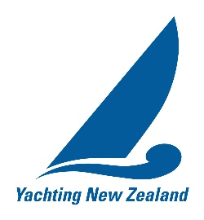
This form confirms the following club delegate(s) will be attending the 2024 YNZ AGM.

Name of club: ______________________________________

Hereby appoints

Name: Position:

Alternate: Position:

as its delegate to exercise the member club’s vote at the Annual General Meeting of Yachting New Zealand to be held online on Tuesday, 12 November 2024 and at any adjournment of that meeting.

Signed: Name: (PRINT)
Position at club: (Delete/circle as applicable) Commodore / Vice-Commodore

Instructions:
This form should be completed by the Commodore or Vice-Commodore of a financial-affiliated club wishing to exercise voting rights at the Annual General Meeting and shall be received at the Yachting New Zealand Office no later than 1600 on Sunday 10 November 2024.

Definitions:
Delegate: A member of a Yachting New Zealand-affiliated club authorised to represent the club (where they are a member) at the Annual General Meeting and can vote on behalf of the club.
Proxy: An individual appointed by a Yachting New Zealand affiliated club to vote on behalf of the club at the Annual General Meeting when no club members are available to attend.

