



# 2024 New Zealand Elliott 5.9 National Championships 7th – 9th March 2024

Notice of Race

**The Organising Authority is the Onerahi Yacht Club Inc (OYC)**

**Beach Rd Onerahi | PO Box 1131, Whangarei |**

The notation ‘[DP]’ in a rule in the Notice of Race means that the penalty for a breach of that rule may, at the discretion of the protest committee, be less than disqualification and the notation [NP] in a rule in the Notice of Race means rules that are not grounds for protest by a boat for breaking that rule. This changes RRS 60.1(a)

# RULES

* 1. The event is governed by the rules as defined in *The Racing Rules of Sailing* and the Elliott 5.9 Class Association*.*
  2. The Yachting New Zealand Safety Regulations Part 1 shall apply.
  3. All boats must supply and clearly display visible two-digit bow numbers with a minimum height of 350mm. The numbers to be used by each boat are those approved by the E5.9 Class Association and will generally be the last digits of the sail number – e.g., “00”. These must be positioned within 1 metre of the bow, on the port and starboard sides of the hull, above the waterline.
  4. Appendix T, Arbitration will apply.

# SAILING INSTRUCTIONS

* 1. The sailing instructions will be available on the Elliott 5.9 website ([https://elliott59.weebly.com](https://elliott59.weebly.com/)) by 12th February 2024. Paper copies will not be printed.

# COMMUNICATION

* 1. The official notice board is located by the entrance to the Marsden Cove Marina Office.

Notices may also be posted in the class ‘WhatsApp’ group and on the Class website.

* 1. On the water, the race committee may make courtesy broadcasts to competitors via VHF radio. The channel will be stated in the SIs.
  2. [DP] While racing, except in an emergency, a boat shall not make voice or data transmissions and shall not receive voice or data communication that is not available to all boats.

# ELIGIBILITY & ENTRY

* 1. The event is open to all boats of the Elliott 5.9 class and who are current members of the class association.
  2. Eligible skippers must enter via by completing the online entry form available on the Elliott Class Association website <https://elliott59.weebly.com/> and paying the required fee.

Entry fees are to be paid into the following bank account:

Account number: 03 - 0675 - 0353023 - 00

Reference: Surname - Boat Name - Sail Number E.g.: Smith – MyBoatFloats - 1234

* 1. To be eligible to compete in this event each entrant and crew member shall be a

financial member of a yacht club recognised by that person’s national authority.

* 1. All boats and keels must be weighed by an authorised class representative in the period between 1st August 2022 and 6th March 2024 to be eligible to compete in regatta. Any boats and keels that have undergone repairs, refurbishing, rebuilding, etc, must also be re-weighed as above.
  2. All sails not previously measured must be measured and signed by an authorised class representative, (which includes YNZ registered sail measurers), prior to the first warning signal. There is no measurement time scheduled for this event.

# FEES

Entry fees are as follows:

|  |  |  |
| --- | --- | --- |
| Class | Standard Entry Fee until 29th February 2024 | Late Fee (additional) |
| Elliott 5.9 | $150 | $50 |

# ADVERTISING

* 1. Boats may be required to display advertising chosen and supplied by the Class Association or individual Organising Authority.

# SCHEDULE

* 1. Registration will take place in the Marsden Cove Marina Car-park between 0800hrs and 0845hrs on 7th March 2024.
  2. The Briefing will be held at 0900hrs in the Marsden Cove Marina Car-park on 7th March 2024.
  3. The dates of racing are 7th, 8th and 9th March 2024.
  4. Number of Races

|  |  |  |  |  |
| --- | --- | --- | --- | --- |
| Class | Total Number  Scheduled: | Races per Day  Scheduled: | Races per day  maximum: | Target time  Minutes: |
| Elliott 5.9 | 12 | 5 | 7 | 45 |

* 1. The scheduled time of the warning signal for the first race each day is 1055hrs.
  2. On the last scheduled day of racing no warning signal will be made after 1430hrs.

# EQUIPMENT INSPECTION

* 1. Boats shall also comply with RRS 78.1 at all times while racing. Refer to NOR 4.4 and

4.5 above.

# VENUE

* 1. Addendum A shows the Event venue
  2. The Racing area will be the waters known as Bream Bay and or Whangarei Harbour. Refer to Addendum B.

# COURSES TO BE SAILED

* 1. The courses to be sailed will be windward/leeward courses.
  2. The target time for each race will be 45 minutes for the leading boat.

# PENALTY SYSTEM

* 1. RRS 44.1 is changed so that the ‘Two-Turns’ penalty is replaced by the ‘One-Turn’

Penalty.

# SCORING

* 1. Five races are required to constitute a series.
  2. (a) When fewer than 6 races have been completed, a boat’s series score will be the

total of her race scores.

(b) When 6 or more races have been completed, a boat’s series score will be the

total of her race scores excluding her worst score.

# SUPPORT PERSON VESSELS

* 1. [DP] Support vessels are permitted but may be subject to restrictions and must comply with all local bylaws.
  2. [DP] All support person vessels shall always have an engine safety cut out switch (kill cord) attached to the driver while the engine is running, unless prior written exemption has been provided by the Organising Authority.

# LAUNCHING & BERTHAGE

* 1. Launching will be at the Marsden Cove Marina Boat Ramp.

# RISK STATEMENT

* 1. RRS 3 states: ‘The responsibility for a boat’s decision to participate in a race or to continue to race is hers alone.’ By participating in this event each competitor agrees and acknowledges that sailing is a potentially dangerous activity with inherent risks. These risks include strong winds and rough seas, sudden changes in weather, failure of equipment, boat handling errors, poor seamanship by other boats, loss of balance on an unstable platform and fatigue resulting in increased risk of injury. **Inherent in the sport of sailing is the risk of permanent, catastrophic injury or death by drowning, trauma, hypothermia or other causes.**

# INSURANCE

* 1. Each participating boat shall be insured with valid third-party liability insurance with a minimum cover of $1,000,000.00 per incident or the equivalent. Certificate of insurance is to be presented at registration.

# PRIZES

* 1. Prizes may be awarded at the discretion of the Class Association or the Organising Authority.

# FURTHER INFORMATION

For further information please contact:

Class Association

Stu Clarke

Phone: 021 890 067

Email:[stu.clarke@xtra.co.nz](mailto:stu.clarke@xtra.co.nz)

Web: [http://www.elliott59.weebly.com](http://www.elliott59.weebly.com/)

**Addendum A – Regatta Venue**

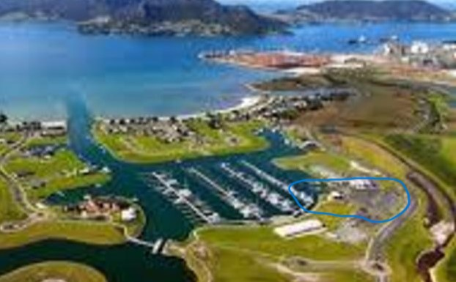

**Attachment B – Racing Areas**

